Worksheet forces and friction
I. Solve each equation for B algebraically.
1. $R=3KB$ 2. $F\frac{K}{B}=2W$ 3. $ZK^{2}=R+B$ 4. $\frac{K}{Q}+L=3{(BX)}^{4}$ 5. $\frac{B}{K}-D=H$

II. Solve each equation trigonometrically for the component vector in terms of the angle and vector.
1.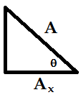 2.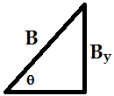 3.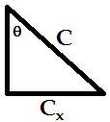 4.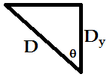

III. Draw a free body diagram for the forces acting on the piano for each of these situations.
1. 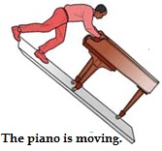 2.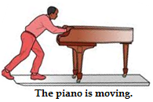 3.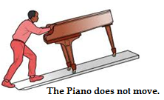

IV. Write a mathematical equation for the sum of the forces in x and y directions for each of these free-body diagrams in terms of the declared variables.
1.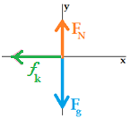2.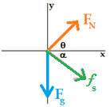3.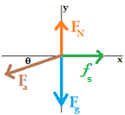4.